Understanding Audio
The Basics: What Makes Audio Sound
"Good good good good vibrations bah bah, excitations."
Well, maybe not excitations but it's all certainly about vibrations. You can probably remember this from science lessons. Something vibrates, it makes the air vibrate, the air vibrates the sensitive bones in your ear, and this sensation is registered in your brain as sound. That's it in a nutshell.
Things that vibrate fast are sensed as being high-pitched, and things that vibrate slowly are low-pitched. Things that make big vibrations are loud, and so on. These vibrations can be graphically represented by a waveform:
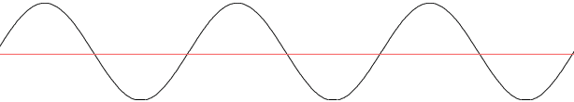
In this diagram, the 'size' of the vibrations is plotted on the vertical (y) axis and the time it was measured at is plotted on the horizontal (x) axis. If you heard this sound, it would be a clear solid note like that made by a tuning fork.
A higher pitched note would have more cycles in the same amount of time - i.e. more peaks and troughs. A quieter note would be one where the peaks and troughs aren't as big.
Digital Audio
The way a natural thing such as sound is digitized is by essentially replicating the way the ear works. Instead of sensitive bones, you have sensitive material that will vibrate just like the bones in your ear do. These vibrations then (using a variety of different methods) cause an electrical current to be created. This translates the amplitude of a sound to an electrical voltage difference. Essentially what you will get is the exact same diagram as above but instead the y axis will be volts. This can then be measured and converted into binary that computers can use. This is digitization.
When sound is digitized, the waveform is reconstructed by measuring the voltage (the y axis) thousands of times a second and storing this reading in computer binary. When you record audio on your pc or when you save or listen to audio files, you may notice that the audio has two properties: bits and sample rate. The most common of these is 16bit 44.1Khz audio as found on CDs. But what do these numbers actually mean?
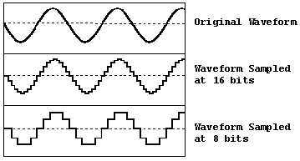
Bits (or Binary digITS)- the easiest way to describe bits in audio is to compare it to video. As you may know, you can set your computer's video display to 8bit, 16bit, 32bit etc. In video terms, the bits are the amount of different colours that can be displayed.
In audio, it's very similar as it's the amount of different voltages (amplitudes) that can be sampled. So, just as 8bit video only has 256 colours, 8bit audio only has 256 different amplitudes it can sample.

Sample Rate is very simple as it's the amount of times every second that the audio is sampled or given a binary number. CDs are sampled at 44.1KHz or 44,100 times a second. That's quite a lot, really - but still nothing compared to video capture ^_^;;
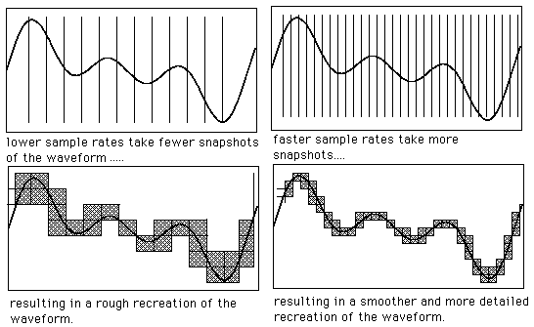
Right, so now you know what 16bit 44.1KHz audio means - 65,536 possible levels measured 44,100 times a second.
This system of digitizing audio is known as Pulse Code Modulation (PCM) and you will notice that in audio compression settings there is almost always a setting for Uncompressed Wav PCM. This is it.
Demons of Digital Audio - Quantization Errors.
It stands to reason that assigning a digital number to an analogue signal can have its problems. Due to there only being a specific amount of 'steps' (quantization levels) that amplitudes can be assigned to there is a considerable amount of rounding errors. Obviously choosing 16bit sampling over 8bit sampling will make these rounding errors less significant as there are more possible levels, as explained earlier.
However, there is another curse, which occurs when trying to give a value to a sample that is outside the digital range. A common situation for this to happen is when trying to sample an analogue signal (with your pc etc.) that is too loud and all you get is garbage noise - which is in this case an example of "clipping". The peaks and troughs of the incoming sound are beyond the range of the sampling system to the tops and bottoms of the peaks are 'clipped' which causes the garbage noise. Problems can also occur in low bit sampling with audio that is too quiet. These types of garbage noise should be avoided at all costs. If you want to increase the volume (gain) without creating garbage data, then see the section on sourcing your audio... this process is called Normalization and I might as well tell you what it does here.
Normalization
In terms of audio, this is a two-stage process which is intended to maximise the volume of your audio sample. The normalization process does the following:
1) Finds the highest amplitude of any wave in the audio
2) Amplifies the entire audio wave so that this amplitude does not exceed the maximum that can be stored in binary - i.e. without clipping.
It is possible to normalize to 95% but essentially the principle is to find the maximum gain without clipping any of your peaks.... of course, if they're clipped already because the analogue input was too loud then there's nothing you can do.
All together now
When you listen to a song, there is generally much more than one instrument being played. Not only is there more than one sound but this sound is also made up of harmonics and other audio wonders that make the instruments and voices sound the way they do. When this is combined together in a waveform it is alters the waveform into something quite indistinguishable from its parts. In fact, it's a bit of a mess:
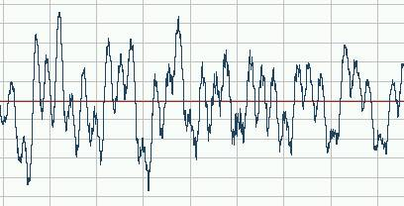
This is a small section from a version of Fly me to the Moon used in Evangelion. In this section we can hear a bass and vocals (but it is a very small section). The wave doesn't really show you much. There are a few recognisable patterns but because the waveforms are combined it is difficult to separate the double bass and the vocals.
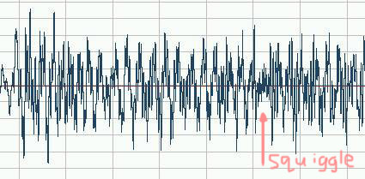
This is a longer section of the same song. In fact it's the "to the" bit of "fly me to the moon". It still doesn't show you much but if you look carefully there is a short, quiet, tight squiggle ¾ of the way along. That's a "tap" noise that's part of the jazz drumming. It is distinguishable because it's much higher pitched and hence has a much higher frequency than the bass or the vocals. In a more complex piece of music, like a rock song, this would be much more difficult to spot.
That's the basics of how sound is digitized and what graphical representations mean. We'll have a further look later when we see how graphical representations can help you with your video.

Audio Compression
OK, you might have noticed that sampling at 44,100 times a second with 65,536 possible values can make a lot of data. If you've ever extracted an audio cd to your PC as a wav then you will know that uncompressed digital audio can be seriously bigger than the mp3s you get off the 'net.
So, how do they compress the audio so much with so little apparent loss in quality?
How Audio Compresses
Well, there are two essential properties to audio compression.
1) Lossless Data compression. This is the zip (Huffman) type of compression where patterns are searched for in order to decrease the amount of data that needs to be stored. It's all math(s) and the net result is that you can make files smaller without getting rid of any of the data. This is useful. In video, there is a codec (COmpressor DECompressor) called HuffYUV that can do this. In audio there are a few codecs that can but a popular lossless codec is FLAC which is quite cool.
2) Psychoacoustic models. OK, this is the main area in which audio compression works. This is the lossy part of the compression where an encoder will throw away information in order to reduce the size. This is based on a mathematical model which attempts to describe what the human ear actually hears - i.e. with the intention of disregarding any information that cannot actually be heard.
Exactly what information to throw away depends on the codec being used. Some codecs are designed to remove certain frequencies so that the compression is best for voices (telephones work with such a system which is why all On Hold music sounds like poo even if it's a tune you like ^^).
Various models have been formulated over the years in order to reduce the sizes of audio files. However the most significant in recent years is undoubtedly the psychoacoustic models used in mpeg1 layer 3 (mp3) compression which I will talk about soon.
The Stages of MP3 Compression
First, let's look at the stages that take place in compressing an audio file. For this example, the mp3 codec is described:
[Note that these stages may not necessarily occur in this order ^_^]
1) The waveform is separated into small sections called frames (think of them as similar to video frames) and it is within each frame that the audio will be analysed. 2) The section is analysed to see what frequencies are present (aka spectral analysis). 3) These figures are then compared to tables of data in the codec that contains information of the psychoacoustic models. In the mp3 codec, these models are very advanced and a great deal of the modeling is based on the principle known as masking which I will talk about in more detail in a moment. Any information that matches the psychoacoustic model is retained and the rest is discarded. This is the majority of the audio compression. 4) Depending on the bitrate, the codec uses the allotted amount of bits to store this data. 5) Once this has taken place, the result is then passed through the lossless Huffman zip-type compression which reduces the size by another 10%. [this is why there is no point in zipping an mp3, it's already been 'zipped']
That's basically what an mp3 compressor does, but what about that psychoacoustic model? What is masking?
Well, the main way that the mp3 codec removes information is by discovering which sounds are apparently undetectable or 'masked' and so cannot be heard. These sounds are then removed (hopefully) without any audible loss in sound.
Psychoacoustics and Masked Sounds:
There are two main types of masking effects - Simultaneous Masking and Temporal Masking.
Simultaneous Masking works under the principle that certain sounds can drown out other sounds when played at the same time. In quiet pieces of music you may be able to hear very subtle sounds such as the breathing of a singer. In a loud song, these elements would no longer be audible but that doesn't mean that the sound has now disappeared. It has also been ascertained that if you play two sounds with the second one at a slightly higher pitch but only slightly quieter, it will be very difficult for the second one to be heard. The brain basically does it's own filtering on the sound. However, if you have two distinct sounds playing, even if you can't hear one, you have much more information. This is the kind of information that is removed and that is the principle of simultaneous masking - the removal of the sounds the brain doesn't hear because of other sounds being present.
Temporal Masking works in a similar way but here the idea isn't that you can't hear one sound because of another one being similar, it's the fact that if you play one sound slightly after another one you wont be able to hear the second one (and vice versa) Again, this is sound information that would be removed.
This all sounds great, doesn't it? - you can remove sounds that you can't hear anyway and get small files. Well, that's kinda true but unfortunately the fact of the matter is that you are getting rid of lots of data and some people can tell.
There is no such thing as an audiophile's mp3 player... an audiophile can tell the difference.
Storing the Data: Bitrates and how they work.
I've touched on this already in the compression description but it's certainly an area worth looking at. You know what 16bit 44.1Khz audio means in terms of your audio sample but what about 128kbps in terms of your compressed file?
Well, what if you only had a certain amount of bits to describe a second of audio? Well, the way the data is stored is by working out how to represent the wave in each frame mathematically. Using a mathematical model known as Discrete Cosine Transform (DCT), a wave can be expressed in terms of a cumulative amount of cosine waves. The more cos waves that are used in the mathematical expression, the closer the result will be to the original waveform. The bitrate will store this data and the complexity and hence accuracy will be limited to the amount of data that can be stored per frame.
In plain terms, 128kbps means that you have 128kbits of data each second to describe your audio. This is an ok amount for a codec such as mp3 and is one of the more popular levels for mp3 encoding. Just like video, the quality of your audio encode will increase if it has more kbits/second to utilize. However, a 192kbps mp3 often sounds much closer to cd quality than 128kbps. It's all about storing data and it's a simple fact that the bitrate is a limiting factor.
CBR and VBR:
Most audio is compressed at a Constant Bitrate (CBR), which means that every second will have the same amount of bits available to it (there is a bit reservoir but essentially you are fixed to the amount of data per second). However, it is obvious that audio is anything but constant. There are quiet parts and loud parts, complicated parts and simple parts but in the end, if you encode with a constant bitrate, they all have to be described with the same amount of bits.
Hence, Xing (who are now part of RealNetworks) developed a system of Variable Bitrate (VBR) encoding in which the bitrate for each frame was scaled based upon the principle that some sections require less bits and others require more. What this means is that for the same filesize, a better quality audio can be encoded.
The debated usefulness of this in terms of music videos will be discussed later in final section about making your distributable video.
Joint Stereo
I figured it would be also worth mentioning the principle of Joint Stereo here as I will be recommending it as an option later on. Basically the idea is that for the most part, left and right channels are very, very similar. So why bother having twice the data for most of the song when lots of it can be duplicated for each channel? This is there the Joint Stereo idea comes in. It compares the left and right channels and works out how much data it can save by making them identical and encoding the data once. This means there will be elements of your wav that are, in effect, mono. These are only elements however and it is a very useful addition for the reduction of file sizes.
There is a secondary pass to the Joint Stereo formation, which is quite clever and uses another psychoacoustic model. The theory is that we are very bad at telling where very high and very low frequency sounds are coming from. A practical example of this is subwoofer speakers - they can be stuck in the corner of the room away from the other speakers and you still can't really tell that the bass is coming from there. Taking this idea into consideration, bass sounds and very high pitched sounds are made mono - because you can't tell the difference.
Of course, with this method you do get a reduction in the stereo separation in your audio. Many people cannot tell the difference but it is there so if you want the best quality you may want to go for the normal stereo mode. Also, it can introduce errors that can't really be regained by increasing the bitrate. If the audio sounds a little poor, try normal stereo.

